|  |  |  |
| --- | --- | --- |
| **LAB221 Assignment** | **Type:** | **Short Assignment** |
| **Code:** | **J2.S.P0009** |
| **LOC:** | **200** |
| **Slot(s):** | **2** |

**Title**

Manage Product

**Background Context**

NA

**Program Specifications**

Use swing library and design UI with your code and database to create a program to manage product, basic information includes:

* Product ID
* Product name
* Price
* Quantity

Category ‘s information includes:

* Category ID
* Category name

Main functions described as below:

***Function details:***

1. Create new category, new product
2. Update an existing product, an existing category
3. Remove an existing product, an existing category
4. Display an existing product information
5. Store product and category in database

***Expectation of User interface:***

The screen should be as:

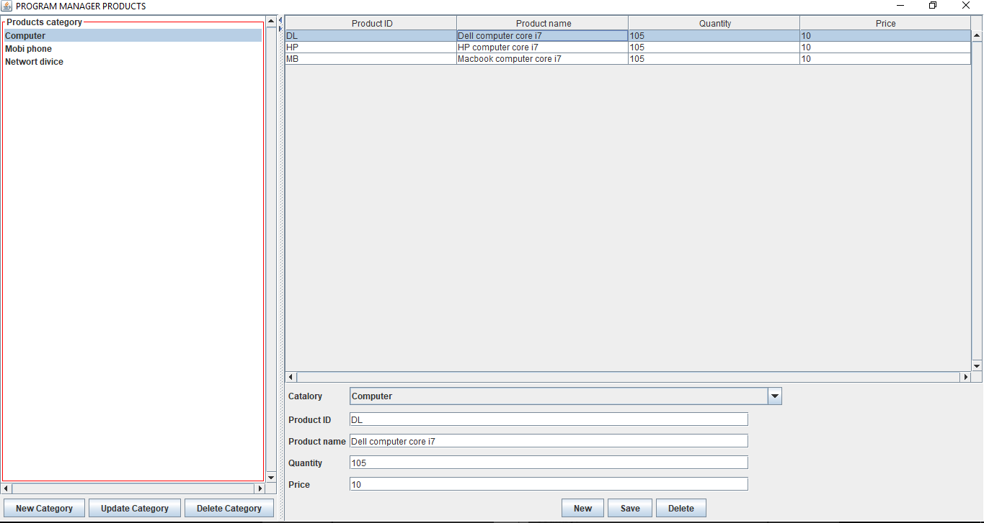

* Enter catelogy information in controls on the form, click Save button, book information is stored and new item added in the Category list
* Select one item in the Category list, product information displays on the right screen, click Remove button, the item is removed from the Category list and the first item information in the Category list will be displayed.

**Guidelines**